**LAB 10**

**K20-1052(S.M.HASSAN ALI)**

**Q1.**

#include <iostream>

using namespace std;

class Shape {

public:

int l,b,h;

virtual float getArea() = 0;

};

class Rectangle : public Shape {

public:

float getArea(){

return l*b;

}

};

class Triangle : public Shape {

public:

float getArea() {

return (0.5*b*h);

}

};

int main() {

Rectangle rec;

Triangle tri;

cout << "Enter the length of the Rectangle: ";

cin>>rec.l;

cout << "Enter the breath of the Rectangle: ";

cin>>rec.b;

cout << "Area of Rectangle: " << rec.getArea()<< endl;

cout << "\nEnter the breath of the triangle: ";

cin>>tri.h;

cout << "Enter the height of the triangle: ";

cin>>tri.b;

cout << "Area of Triangle: " << tri.getArea()<< endl;

return 0;

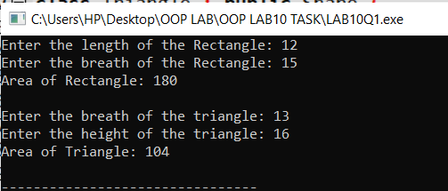}

**Q2.**

#include <iostream>

using namespace std;

class Car{

public:

string model;

int price;

Car(string a):model(a){

}

virtual void setPrice()=0;

};

class Colour:public Car{

public:

Colour(string a):Car(a){

}

void setPrice(){

price=55;

cout<<"The price of the colour is: "<<price<<endl;

}

};

class Company:public Car{

public:

Company(string a):Car(a){

}

void setPrice(){

price=55555;

cout<<"The price of the car of company AUDI is: "<<price<<endl;

}

};

int main(){

Colour c("AUDI");

Company c1("AUDI");

cout<<c.model<<endl;

c.setPrice();

c1.setPrice();

}

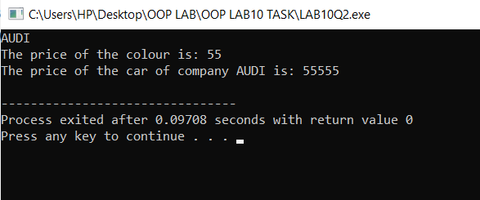

**Q3.**

#include <iostream>

using namespace std;

class Person{

public:

string name;

int id;

float bon,sal;

virtual void getdata()=0;

virtual void display()=0;

virtual void bonus()=0;

};

class Admin: virtual public Person{

public:

void getdata(){

cout<<"Enter the name of ADMIN: ";

cin>>name;

cout<<"Enter the id: ";

cin>>id;

cout<<"Enter the salary: ";

cin>>sal;

cout<<endl;

}

void bonus(){

float ff;

cout<<"Enter the percentage of bonus for admin btw 5-15: ";

cin>>ff;

bon=sal+(sal*ff)/100;

cout<<endl;

}

void display(){

cout<<"NAME: "<<name<<endl;

cout<<"ID: "<<id<<endl;

cout<<"SALARY: "<<sal<<endl;

cout<<"SALARY AFTER BONUS: "<<bon<<endl;

cout<<endl;

}

};

class Account: virtual public Person{

public:

void display(){

cout<<"NAME: "<<name<<endl;

cout<<"ID: "<<id<<endl;

cout<<"SALARY: "<<sal<<endl;

cout<<"SALARY AFTER BONUS: "<<bon<<endl;

if(sal > 25000 && bon >8){

cout<<"The person has a filer account "<<endl;

}

else{

cout<<"the person needs to have a filer account asap "<<endl;

}

cout<<endl;

}

void getdata(){

cout<<"Enter the name of accounts: ";

cin>>name;

cout<<"Enter the id: ";

cin>>id;

cout<<"Enter the salary: ";

cin>>sal;

cout<<endl;

}

void bonus(){

float ff;

cout<<"Enter the percentage of bonus for account btw 5-15: ";

cin>>ff;

bon=sal+(sal*ff)/100;

cout<<endl;

}

};

class Masterclass: public Account,public Admin{

public:

void getdata(){

Admin:: getdata();

Account::getdata();

}

void bonus(){

Admin::bonus();

Account::bonus();

}

void display(){

Admin::display();

Account::display();

}

};

int main(){

Admin a,*ptr;

Account a1,*p;

Masterclass m,mm;

ptr=&m;

ptr->getdata();

ptr->bonus();

ptr->display();

}

